IAS SOFTWARE TESTING REPORT

Project: IAS Software
Tester: Kavya
Testing Type: Manual Testing
Environment: Localhost (Developer Laptop)
Browser: Google Chrome
Automation Status: Not Automated (Application hosted in localhost)
Date: 12-Mar-2026

Table of Contents

1. Project Overview
2. Test Environment
3. Testing Scope
4. Modules Tested
5. Test Execution Summary
6. Module Wise Test Cases
7. Defect Summary
8. Testing Conclusion
9. Screenshots

1. Project Overview
IAS Software is a web-based application tested in the developer's localhost environment. The purpose of testing is to verify that the core functionalities such as authentication, user management, dashboard access, and code management modules are working as expected.

2. Test Environment

Parameter | Details
Application Environment | Localhost (Developer Laptop)
Browser | Google Chrome
Testing Type | Manual Testing
Automation | Not performed
Reason | Application not deployed in test/staging environment

3. Modules Tested

Sign In
Create Account
Forgot Password
Reset Password
OTP Verification
Profile
Dashboard
Code Master
Code Details

4. Test Execution Summary

Total Test Cases | Passed | Failed
9 | 7 | 2

5. Module Wise Test Cases

Test Case ID | Module | Scenario | Expected Result | Actual Result | Status
TC_LOGIN_01 | Sign In | Verify login page heading | Heading should display 'Sign In' | Displays 'Sign Up' | Fail
TC_ACC_01 | Create Account | Verify user registration | Account should be created | Account created successfully | Pass
TC_FP_01 | Forgot Password | Verify forgot password | OTP should be sent | OTP sent successfully | Pass
TC_OTP_01 | OTP Verification | Verify OTP expiry after 2 minutes | OTP should expire | OTP still accepted | Fail
TC_RP_01 | Reset Password | Verify reset password | Password reset successfully | Password reset successfully | Pass
TC_PRO_01 | Profile | Verify profile details | Profile should display correctly | Displayed correctly | Pass
TC_DASH_01 | Dashboard | Verify dashboard load | Dashboard should load | Dashboard loaded | Pass
TC_CM_01 | Code Master | Verify code creation | Code should save | Code saved | Pass
TC_CD_01 | Code Details | Verify code details display | Details should display | Details displayed | Pass

6. Defect Summary

Defect ID | Module | Issue | Severity
BUG_01 | Login | Heading shows Sign Up instead of Log In | Medium
BUG_02 | OTP | OTP does not expire after 2 minutes | High

7. Screenshots

Sign In
Insert screenshot of this module here with description of the functionality tested.

Create Account
Insert screenshot of this module here with description of the functionality tested.

Forgot Password
Insert screenshot of this module here with description of the functionality tested.

Reset Password
Insert screenshot of this module here with description of the functionality tested.

OTP Verification
Insert screenshot of this module here with description of the functionality tested.

Profile
Insert screenshot of this module here with description of the functionality tested.

Dashboard
Insert screenshot of this module here with description of the functionality tested.

Code Master
Insert screenshot of this module here with description of the functionality tested.

Code Details
Insert screenshot of this module here with description of the functionality tested.

8. Testing Conclusion
Manual testing of IAS Software was completed in the developer's localhost environment. Major functionalities such as account creation, password reset, dashboard navigation, and code management modules are functioning correctly. Two issues were identified during testing related to login page heading and OTP expiry. These defects have been reported to the development team for further resolution.

Attached Screenshots from Testing
Figure 1
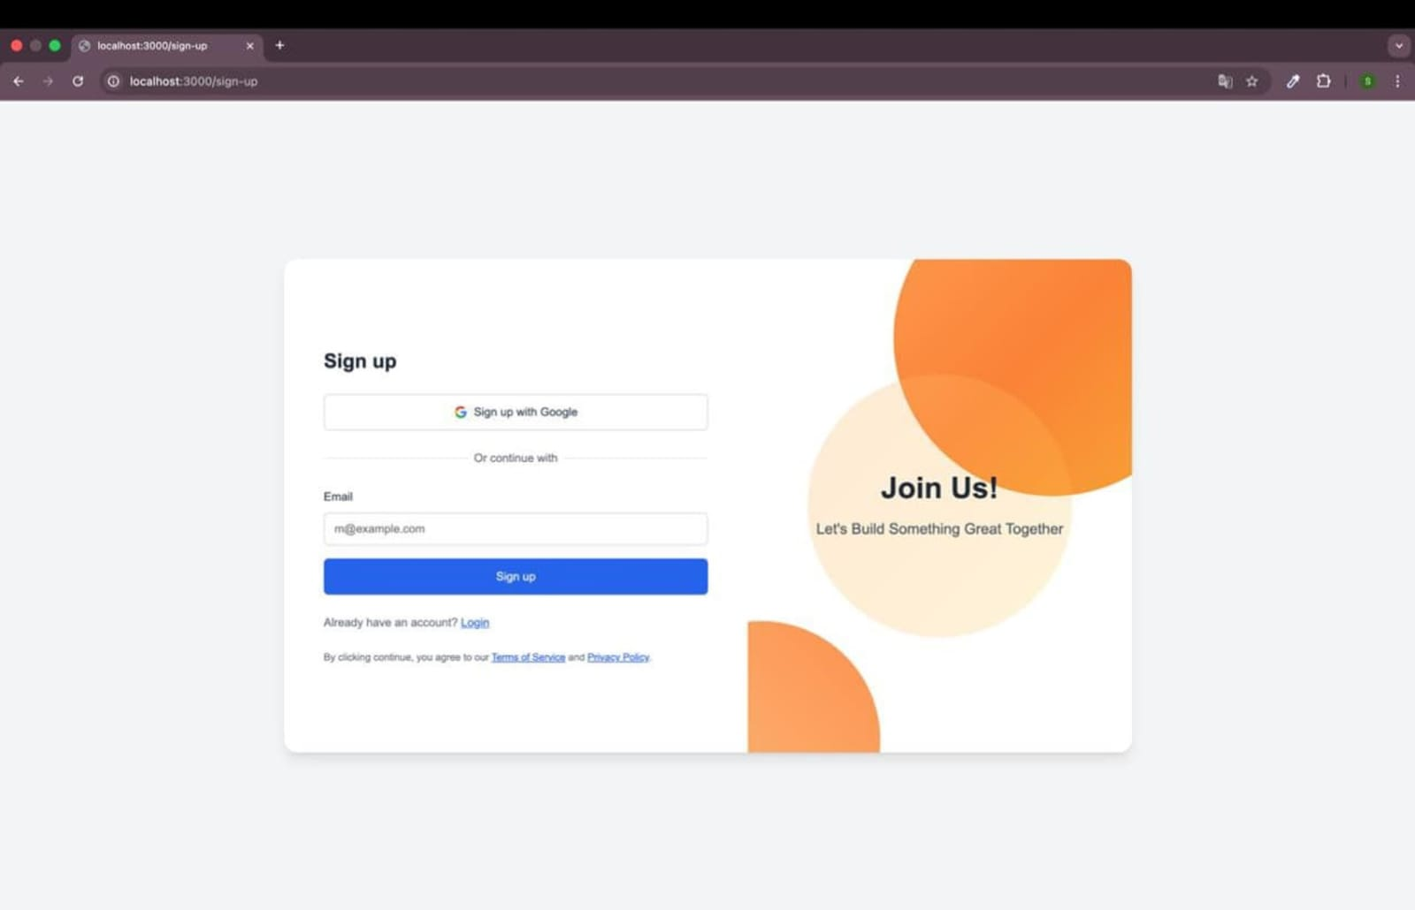

Figure 2
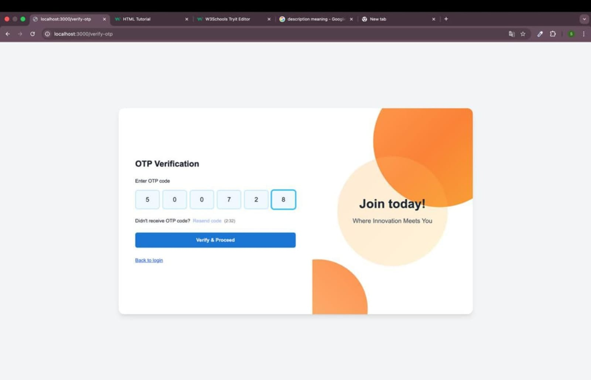
Figure 3
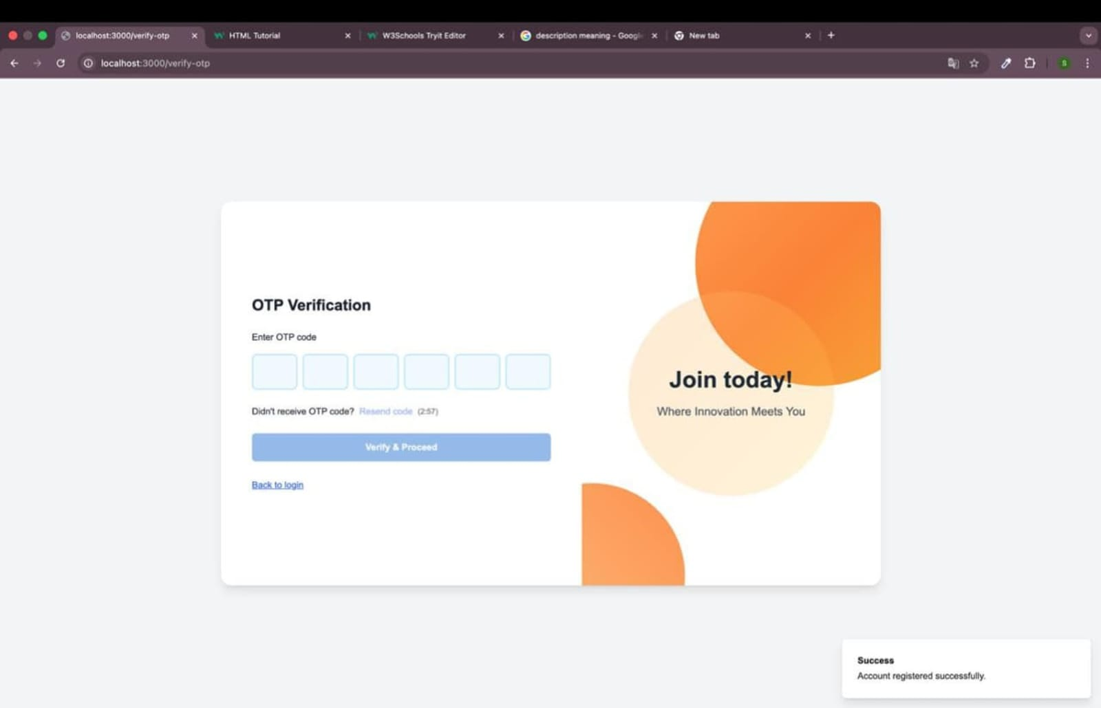

Figure 4
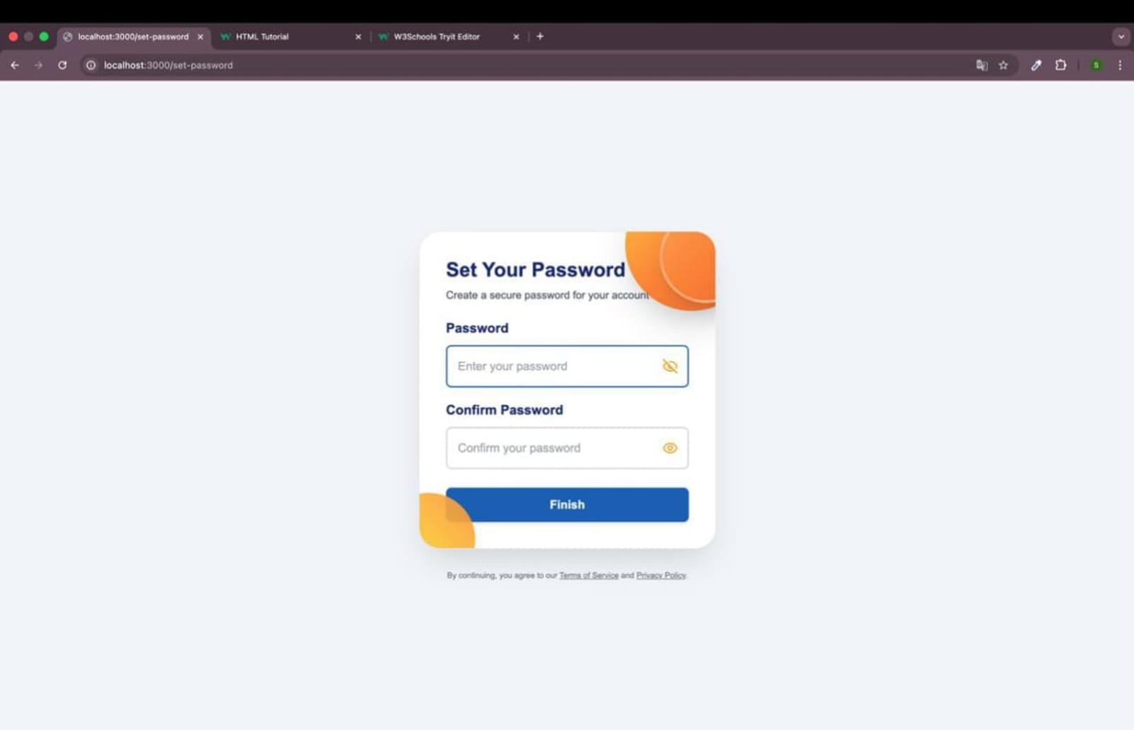
Figure 5
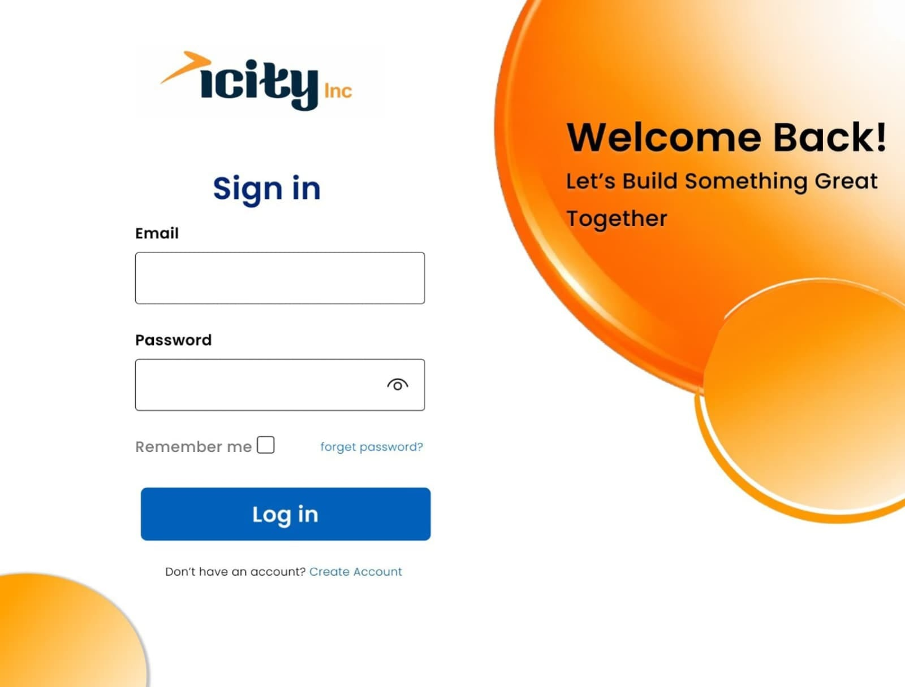

Figure 6
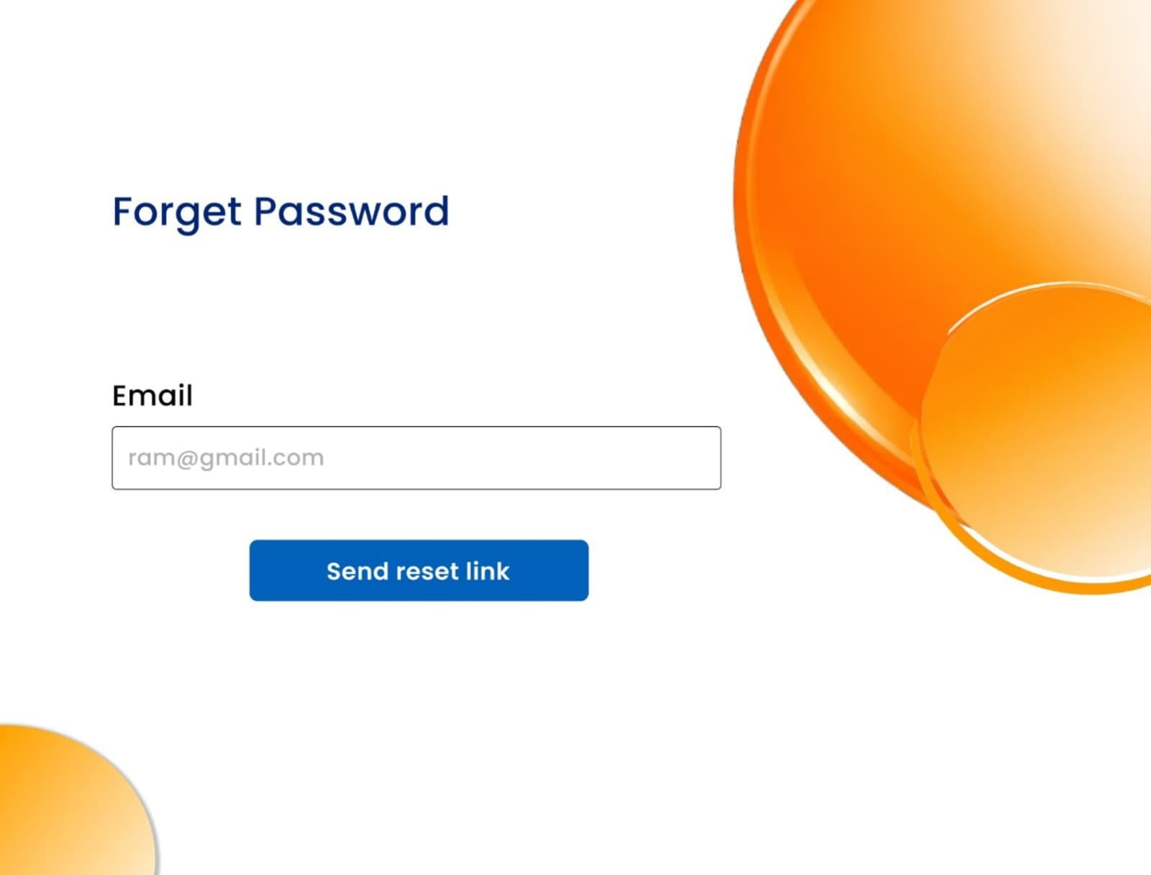
Figure 7
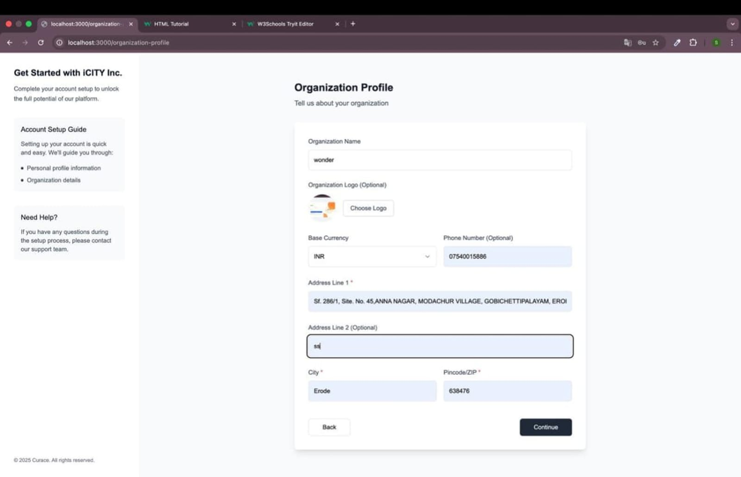

Figure 8
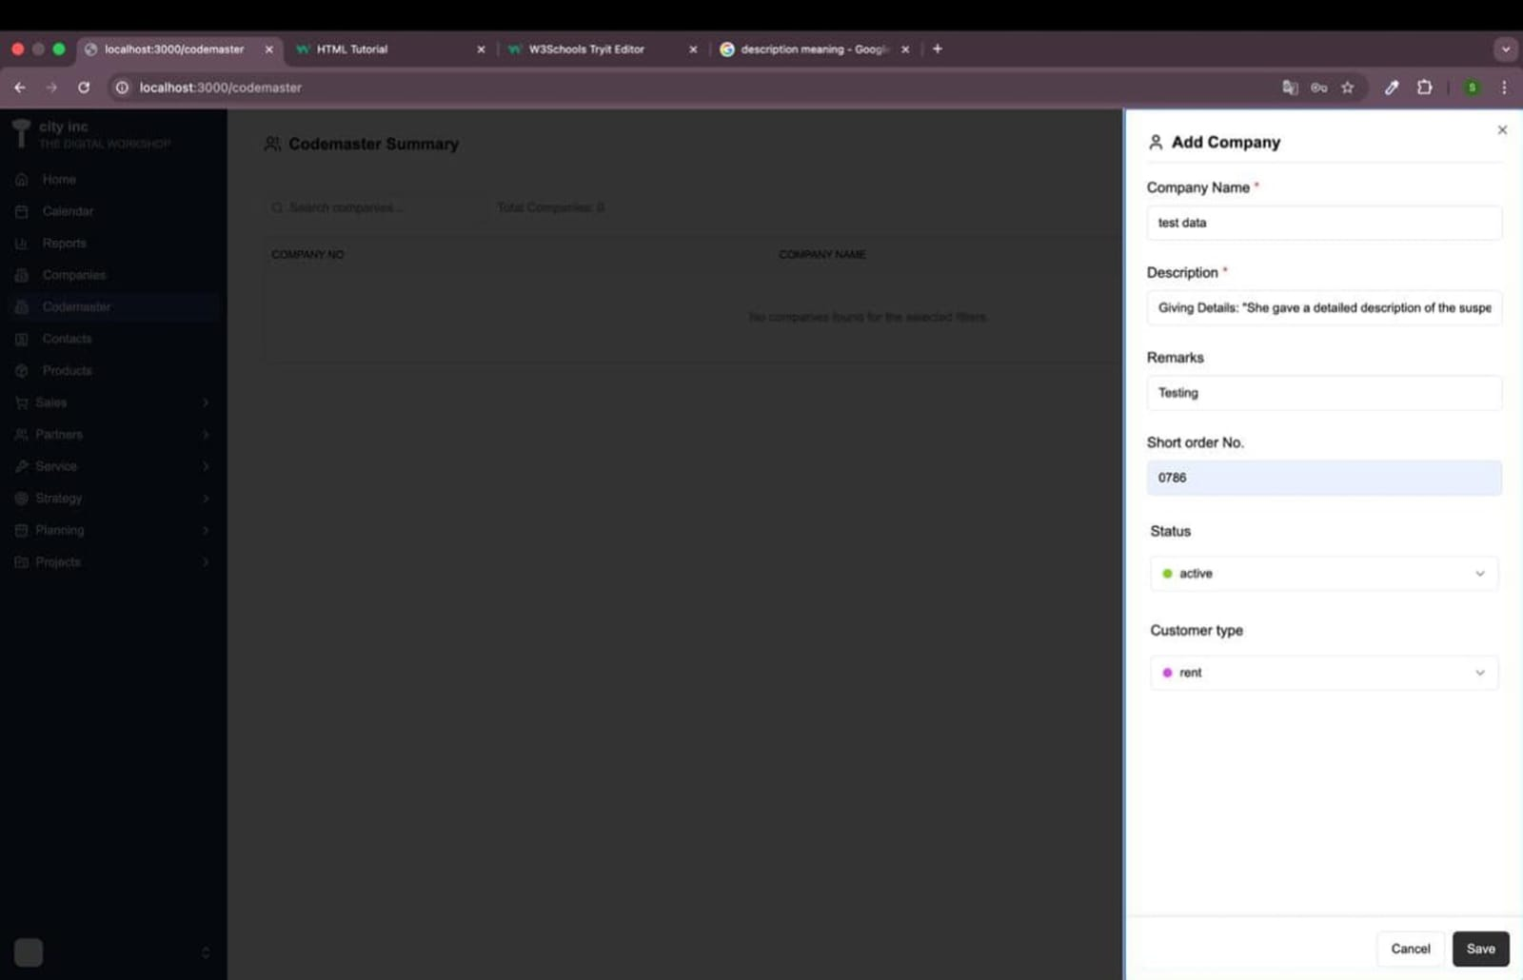

Figure 9
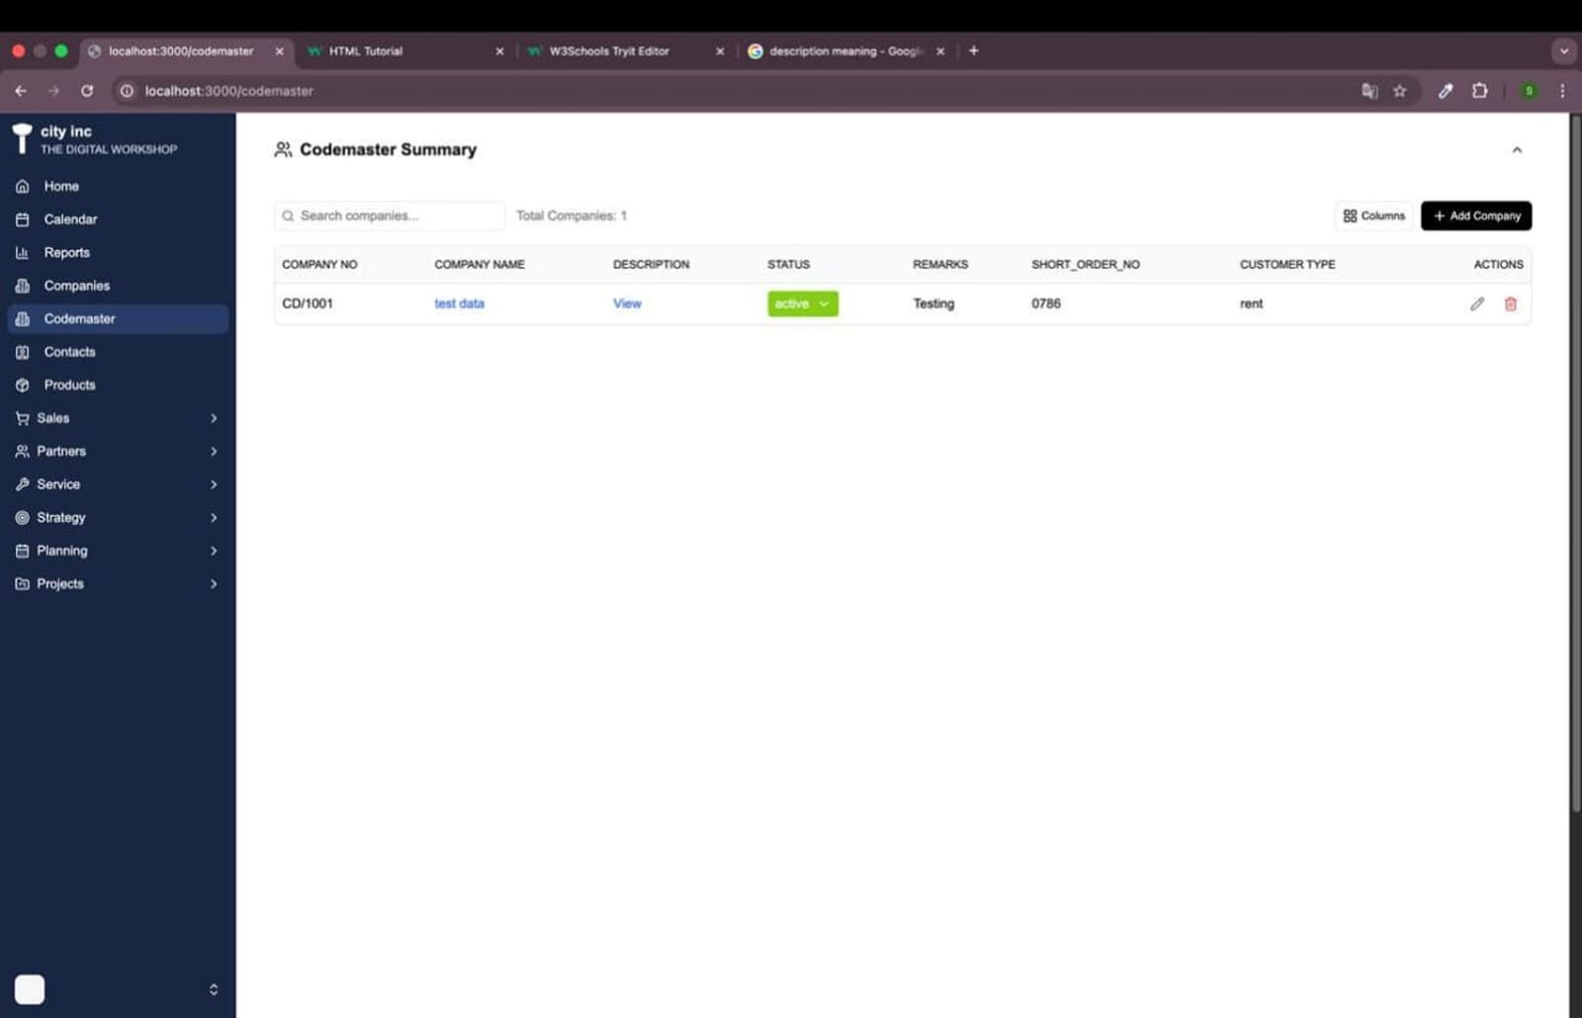

Figure 10
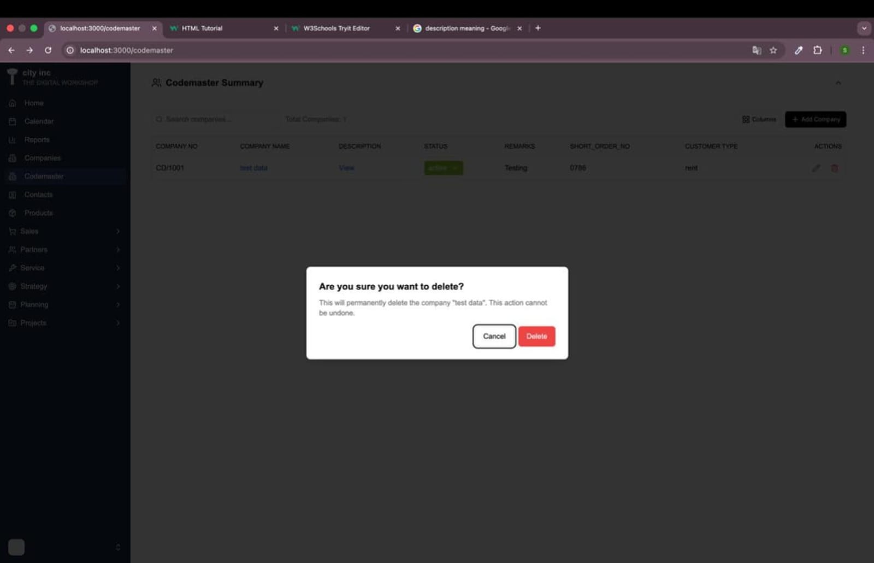

Figure 11
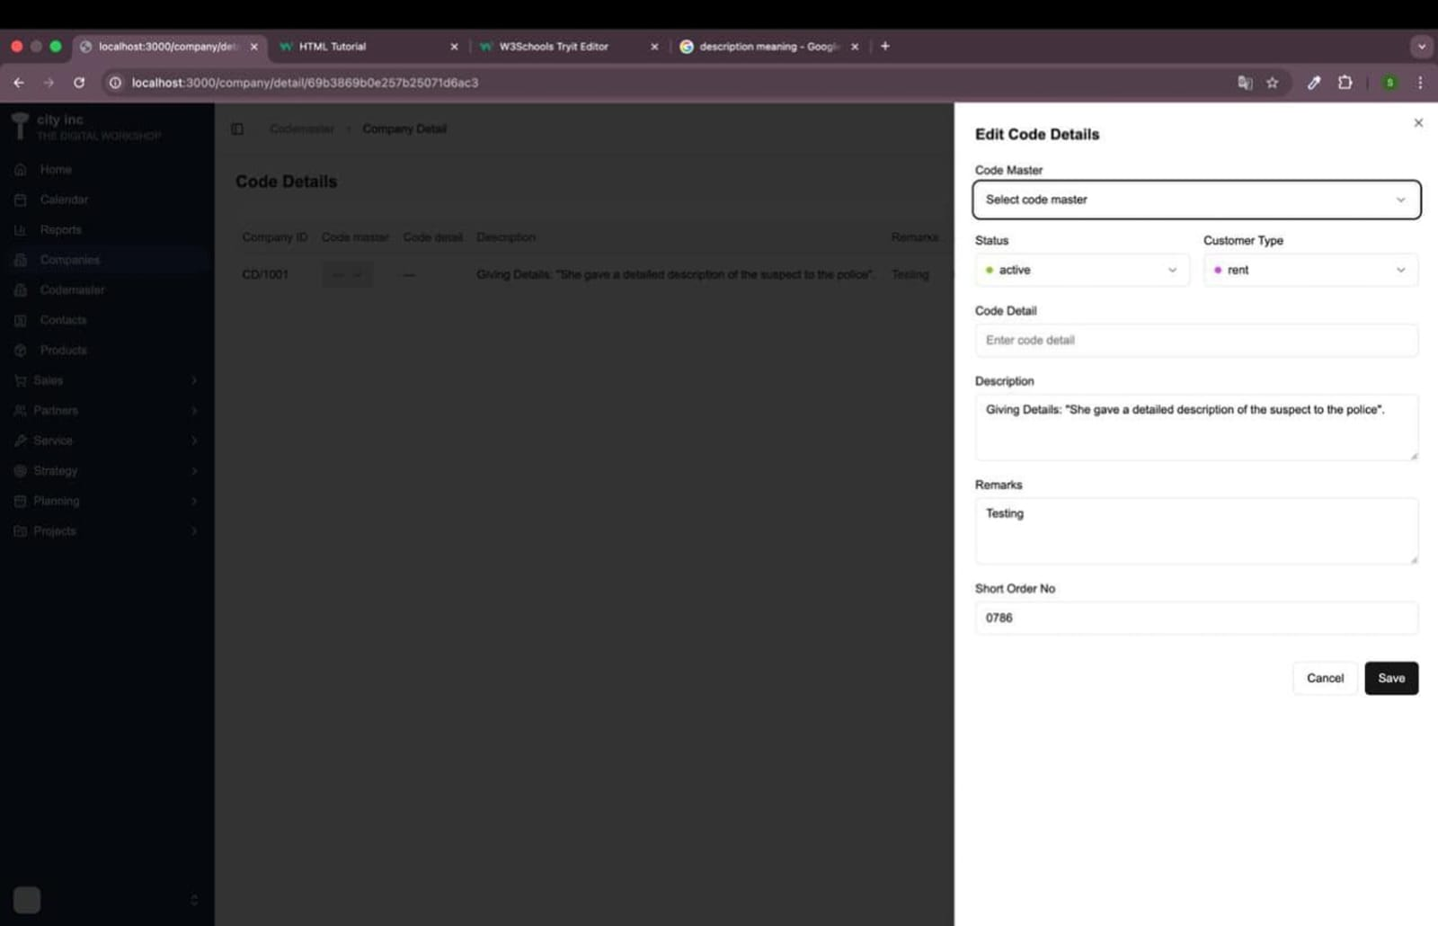

Figure 12
